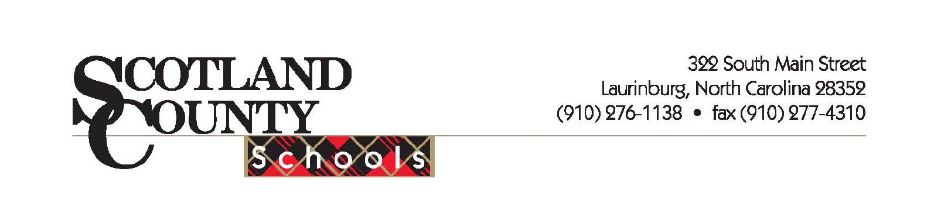

Scotland County Schools
322 South Main Street
Laurinburg, North Carolina 28352
Phone: (910) 276-1138
Fax: (910) 277-4311

Federal ID# 56-0815686

Credit References:

Company Contact Phone Number
Toshiba Sharon Jones 800-768-4349 ext. 420
Pitney Bowes Customer Service 800-322-2200
Petroleum Traders Customer Service 800-348-3705
US Foodservice Customer Service 800-624-5244 ext.6330
Pet Dairy Customer Service 423-283-5722
Office Depot Karen Whitfield 1-888-213-8948 ext. 5448

Bank Reference:

First Bank
601 South Main Street
Laurinburg, North Carolina 28352
(910) 277-0801



