# PowerTeacher PRO

**Middle Schools (Year-Long Classes)**

The grade verification process should be completed when all students are in the correct class, all grades are accurate, and there are no blank grades. This should only be completed for classes you assign grades to.

1. Select the current term (Q1, Q2, Q3, Q4)
2. Select a current class.
3. Click on the A+ Grading charm.
4. Click on Comment Verification.
5. Make sure that you are working with the current term grades

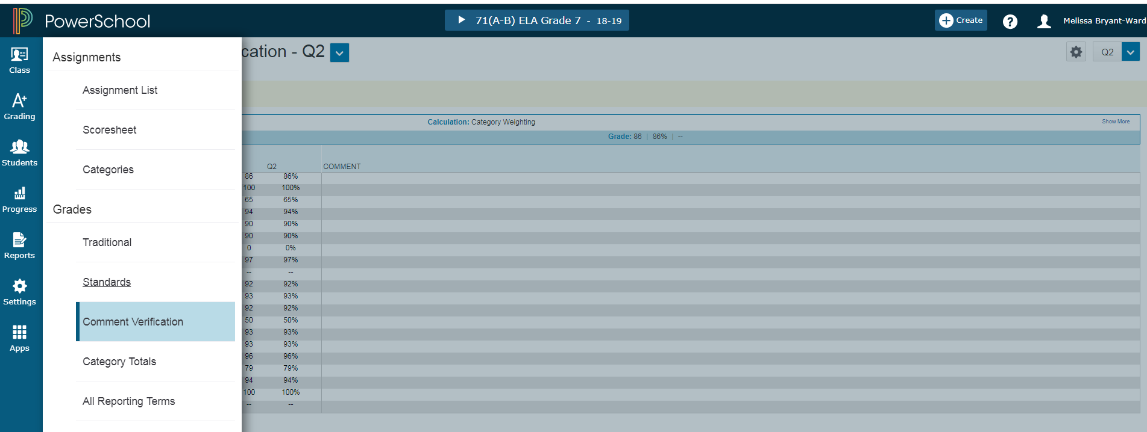

To Add Comments

1. Click on the Current Term (Q1, Q2, Q3, Q4) grade beside the student name. The Score Inspector shows on the right.
2. Click the Comment icon in the Score Inspector.
3. Click Comment Bank and select the + sign to add comment. The comment will appear beside the student’s score cell. Click Save.
4. Comments must be added for the current term in order for them to show on the report card.

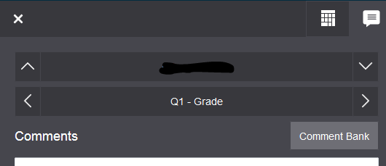

To save and verify grades/comments. Make sure student current term grades are correct. At the bottom of the screen, click the final grade status button.



This screen will appear. Click the box that all current term grades are complete and place a comment in the box that all term grades are verified and correct with the date. Save.

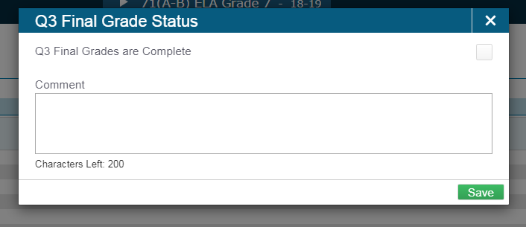

With the Comment Verification screen showing, click **Ctrl-P** and send to the printer of your choice. **Repeat ALL steps for each class with grades.**

**Sign, date, and turn in the signed pages by the due date set by your principal/data manager.**

**Note: At the end of each semester, you must complete this process for the quarter and the semester. For example, when you complete Q2, you must also verify S1. And, when you complete Q4, you must verify S2, and F1.**

Verify the S1 (Semester) grades for each class and Print the All Reporting Terms Screen

1. Switch to the S1 reporting period.
2. Click on the A+ Grading charm.
3. Click on All Reporting Terms.
4. You will see the two nine-week term grades and the calculated semester grades.
5. If you need to change a semester grade, click on the grade under the S1 column and change the number grade and the percent grade in the score inspector.
6. Make sure you click the final grade status button, click the F1 grades are complete box, place a comment that all final grades are verified/correct, and save.
7. Print the screen after verifying the semester grades. Use **Ctrl-P** and send to the printer of your choice.

**V**erify the F1 (Final) grades for each class and Print the All Reporting Terms Screen

1. Switch to the F1 reporting period.
2. Click on the A+ Grading charm.
3. Click on All Reporting Terms.
4. You will see the two nine-week term grades and the calculated final grades.
5. If you need to change a final grade, click on the grade under the F1 column and change the number grade and the percent grade in the score inspector.
6. Make sure you click the final grade status button, click the F1 grades are complete box, place a comment that all final grades are verified/correct, and save.
7. Print the screen after verifying the final grades. Use **Ctrl-P** and send to the printer of your choice.