## End of Grading Period Verification for Report Card Grades

Power Teacher PRO

Elementary Art/Music/PE Teachers (Grade Levels 3rd – 5th)

The grade verification process should be completed when all students are in the correct class, all grades are accurate, and there are no blank grades. This should only be completed for classes you assign grades to.

1. Select the current term (Q1, Q2, Q3, Q4, or F1) from the drop down screen.
2. Select a current 3rd, 4th, or 5th grade class.
3. Click on the A+ Grading charm.
4. Click on Traditional under Grades.

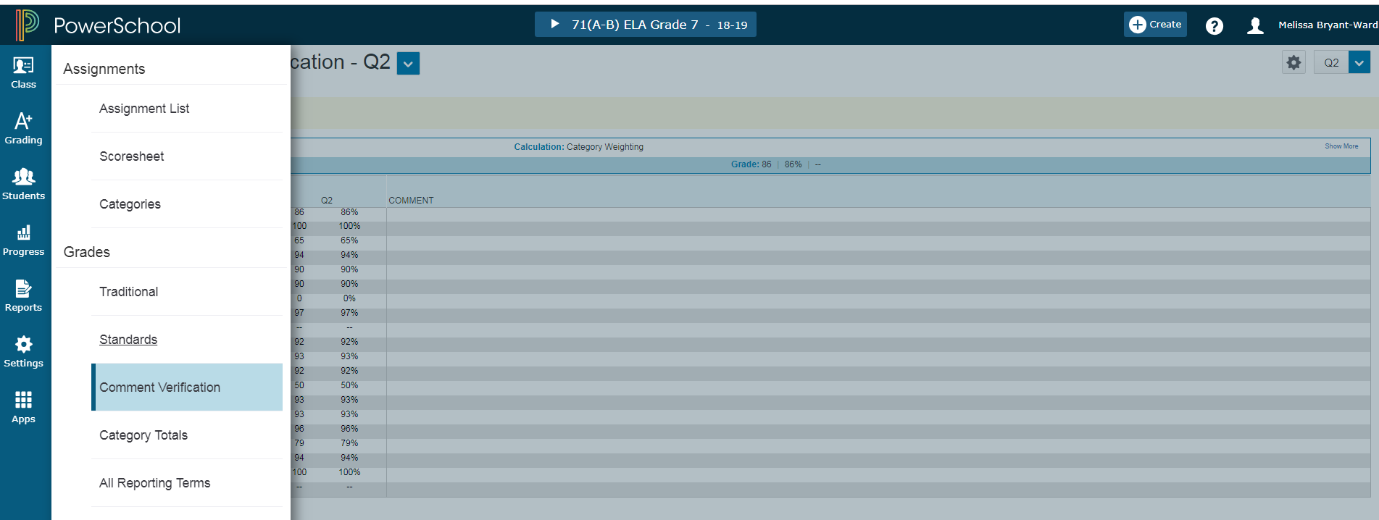

Click on the dash (--) under the **Current Grading Period** ( column beside the first student name. The score inspector shows on the right. Click on Codes. Click on “S” in the Special Codes box.

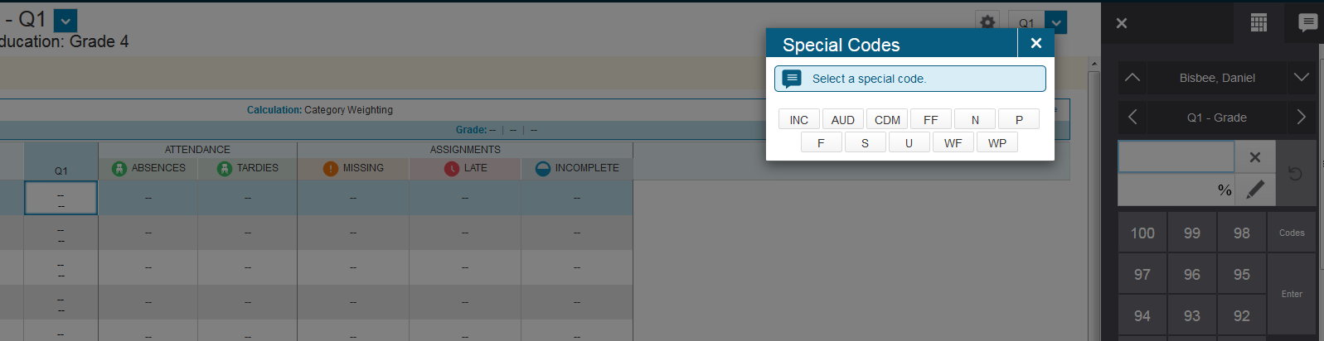

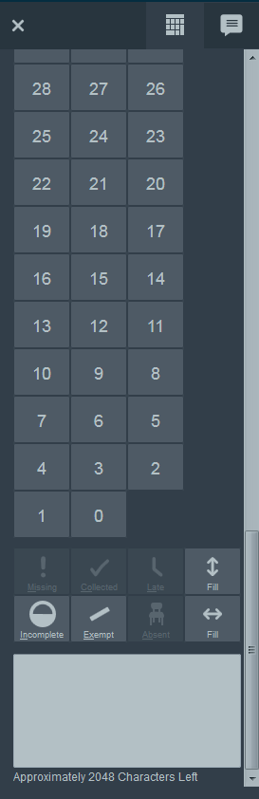

Scroll down to the bottom of the score inspector. Click on the Vertical Fill button. Click OK. If you have individual students that need a “N” or “U”, click on the **Current Grading Period** beside their name and make the change.

Vertical Fill Button

Click back on the A+ Grading charm.

Vertical Fill Button

Click on Comment Verification.

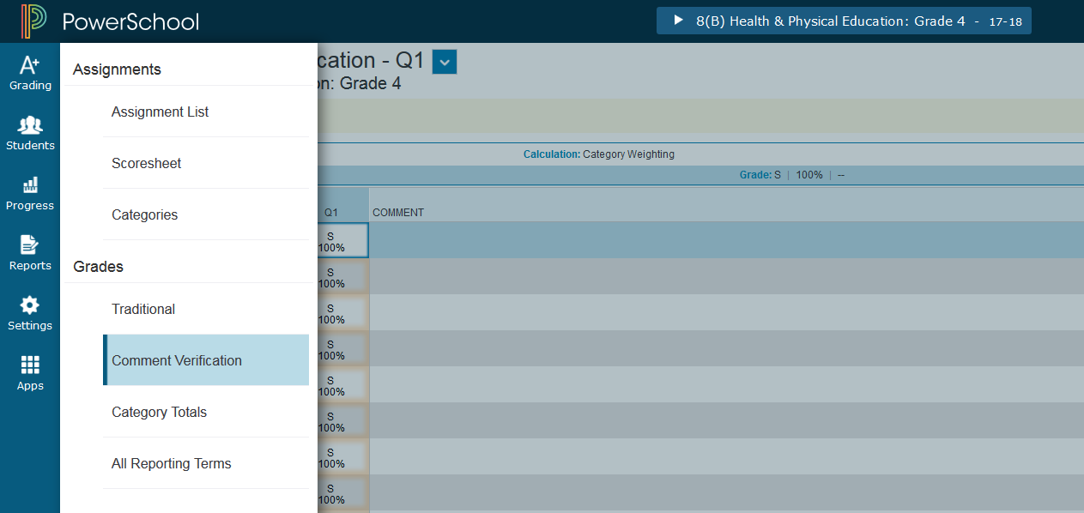

To Add Comments

1. Click on the Current Term (Q1, Q2, Q3, Q4, or F1) grades beside the student name. The Score Inspector shows on the right.
2. Click the Comment icon in the Score Inspector.
3. Click Comment Bank and select a comment. A blue Comment icon appears in the student’s score cell. Click Save. You can click on the icon to read the comment.
4. Comments must be added for the current term in order for them to show on the report card.

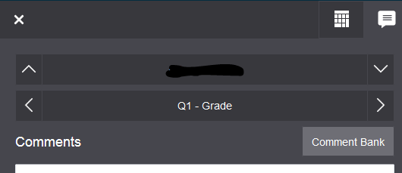

To save and verify grades/comments. Make sure student current term grades are correct. At the bottom of the screen, click the final grade status button.



This screen will appear. Click the box that all current term grades are complete and place a comment in the box that all grades are verified and correct with the date verified. Save.

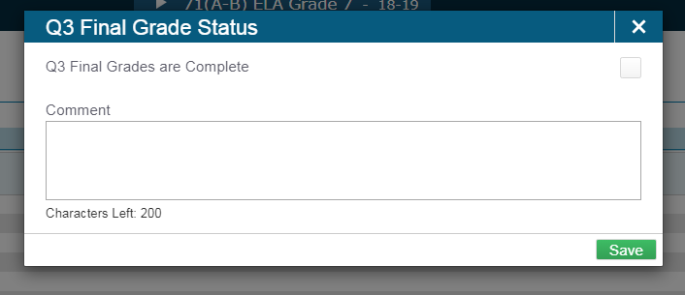

With the Comment Verification screen showing, click **Ctrl-P** and send to the printer of your choice. **Repeat ALL steps for each class with grades.**

Sign and date all the print outs.

**Turn in the signed pages by the due date set by your principal/data manager.**

Important Reminder: At the end of each school year, THIS PROCESS MUST BE COMPLETE FOR F1. After you verify Quarter 4 grades, complete the entire process for F1.