**Timesheet**

This screen displays the employee’s current Timesheet. The pay period dates default for display. The District’s defined work week begin day will be reflected in the start date of the date ranges displayed.  So, if your District has Monday set as the first day of the work week, the date range displayed will be Monday through Tuesday.

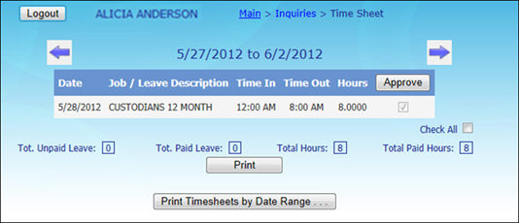

* Click the https://www.linq.com/Files/TK/Content/image4.gifor https://www.linq.com/Files/TK/Content/image5.gifbuttons to display a different timesheet.
* Click **Approve** to mark all unapproved time timesheets as approved by you.
* Click the https://www.linq.com/Files/TK/Content/image5.jpg button to navigate to the page that allows the user to enter custom date range for report.

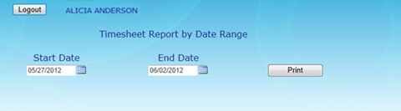

o   Select dates from the **Start Date** and **End Date** fields.

* Click **Print** to print a copy of your time sheet.