Daily Attendance Entry Instructions for Teachers

On the Start Screen, click on the Single Chair icon beside your **Homeroom Class**.

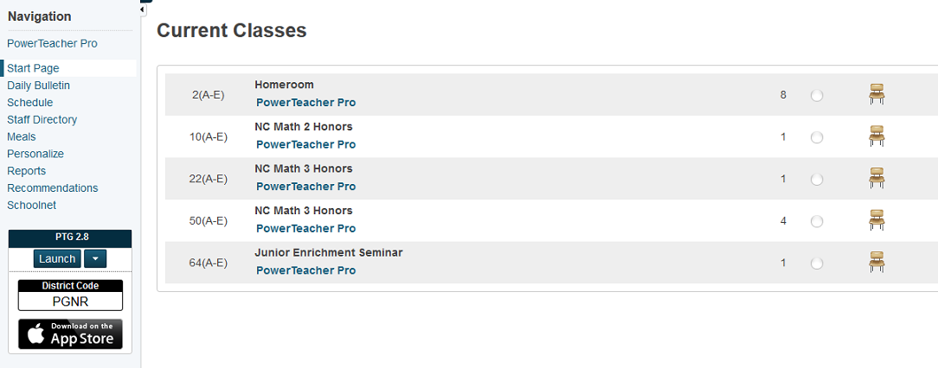

On the attendance entry screen, change the Attendance Code drop-down from (Present) to the needed code. Click in the field beside the student’s name to enter the specified attendance code for that student. If needed, change to a different attendance code. When complete, click on the Submit button. The bullet beside the chair icon will turn green. If all students are present, go to the attendance entry screen, click on submit.

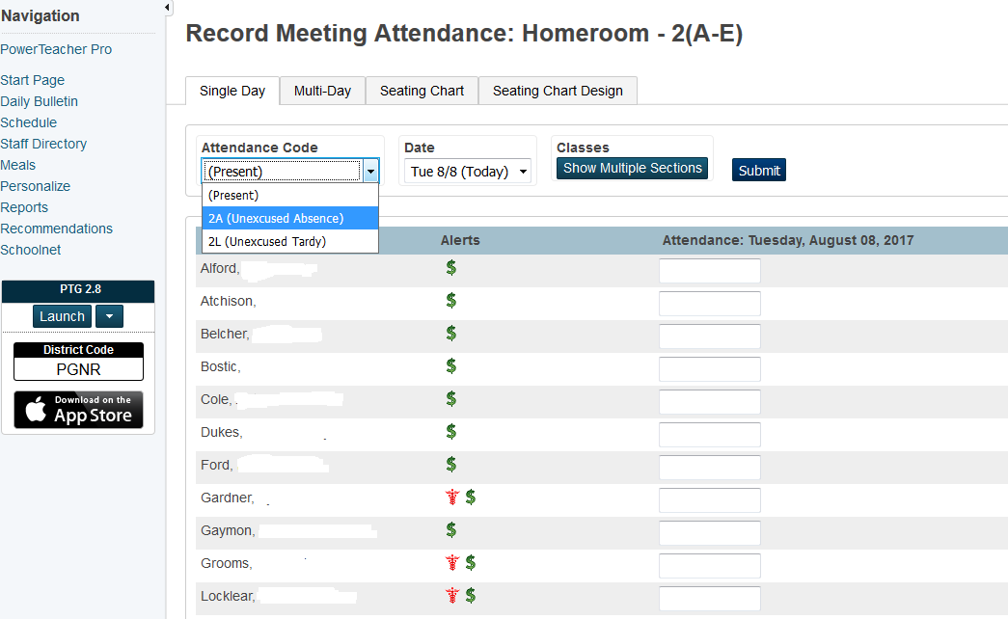

Attendance is entered in PowerTeacher for the current date ONLY. You will need to get an Attendance Correction Form from the office for previous dates’ corrections. DO NOT enter attendance for any other classes in PowerTeacher other than your Homeroom class!!!